**Kulsoom Khurshid**

**SP20-BCS-044**

**ASSIGNMENT #1**

**QUESTION 1:**

1. Given Data:

R1 = 500 kbps, R2 = 2 Mbps, R3 = 1 Mbps

Solution:

Throughput = min {R1, R2, R3}

Throughput = min {500 x 103 bps, 2 x 106 bps, 1 x 106 bps}

Throughput = 500000 bps or 500kbps

1. Given Data:

File size = 4,000,000 bytes = 4,000,000 x 8 = 32,000,000 bits

Throughput = 500000 bps

Solution:

Time to transfer file to Host B = 32,000,000 bits / 500000 bps

Time to transfer file to Host B = 64 secs

1. Given Data:

R1 = 500 kbps, R2 = 100 kbps, R3 = 1 Mbps

Solution:

Throughput = min {R1, R2, R3}

Throughput = min {500 x 103 bps, 100 x 103 bps, 1 x 106 bps}

Throughput = 100000 bps or 100kbps

Given Data:

File size = 4,000,000 bytes = 4,000,000 x 8 = 32,000,000 bits

Throughput = 100000 bps

Solution:

Time to transfer file to Host B = 32,000,000 bits / 100000 bps

Time to transfer file to Host B = 320 secs

**QUESTION 2:**

Solution:

If the end system A wants to send a large file to another end system B, it needs to breakdown the file into **chunks**. Later on, **header is assigned to each chunk which results in packet**. A single large file has multiple packets. Every packet has the destination address where it needs to be send in its header section. When the packet arrives at the packet switch, **the packet header (destination address)** is examined and based on the destination address outbound link is decided from the forwarding table.

Each packet contains the **destination address in its header section**. When packet reaches the switch, the destination address on the header of the **packet determine the outgoing link** on which it should be forwarded. This is analogous to asking which road to take.

**QUESTION 3:**

1. Solution:

Circuit switched network would be more appropriate for this application because the behavior of the application has long sessions with predictable bandwidth requirements. The transmission rate is constant and steady so, bandwidth can be reserved for each session without wasting.

1. Solution:

There will be no congestion as there will be minimum queuing due to data rates being less than capacities of each and every link. Each link has sufficient amount of bandwidth to manage the sum of all of the application data rates. Hence, the network does not required any congestion control mechanism.

**QUESTION 4:**

1. Given Data:

Propagation speed = 100 km/hour

Distance = d = 175 km

Solution:

Delay time = d/propagation speed = 175 / 100 = 1.75 hrs.

Time for 3 tollbooths to reach 10 cars = 2 x 3 = 6 mins.

Delayend-to-end = 1hr 45mins + 6 mins = 1hr 51mins.

1. Given Data:

Propagation speed = 100 km/hour

Distance = d = 175 km

Solution:

Delay time = d/propagation speed = 175 / 100 = 1.75 hrs.

Time for 3 tollbooths to reach 8 cars = 12 x 3 x 8 = 288 sec = 4 mins 48 secs.

Delayend-to-end = 1hr 45mins + 4 mins 48 secs = 1hr 49mins 48 secs.

**QUESTION 5:**

1. Given Data:

Transmission rate = 10 x 106 bps

Transmission rate required by user = 200 x 103 bps

Solution:

Number of users = 10 x 106 bps / 200 x 103 bps

Number of users = 50 users

Given Data:

Percentage user transmitting = 10%

Solution:

Probability = P (user transmitting) = 0.1

Given Data:

=Number of users = 120

Solution:

P (n) = NCn (p)n (q)N – n

P (n) = 120Cn (0.1)n (0.9)120 – n

Solution:

P (51 or more users) = 1 – P( x < 51)

= 1 – 120C50 (0.1)50(0.9)120 - 50

**QUESTION 6:**

Solution:

I = La/R

Queuing delay = I x L / R (1 – I)

Total delay = queuing delay + transmission delay

= IL/R (1 – I) + L / R

= IL + L (1 – I) / R (1 – I)

= L (I + 1 – I) / R (1 – I)

= L / R (1 – I)

Solution:

Transmission delay= x = L /R

Traffic Intensity = I = (L x a) / R = (x * a)

Total delay = L / R (1 – I)

= x / (1 – xa)

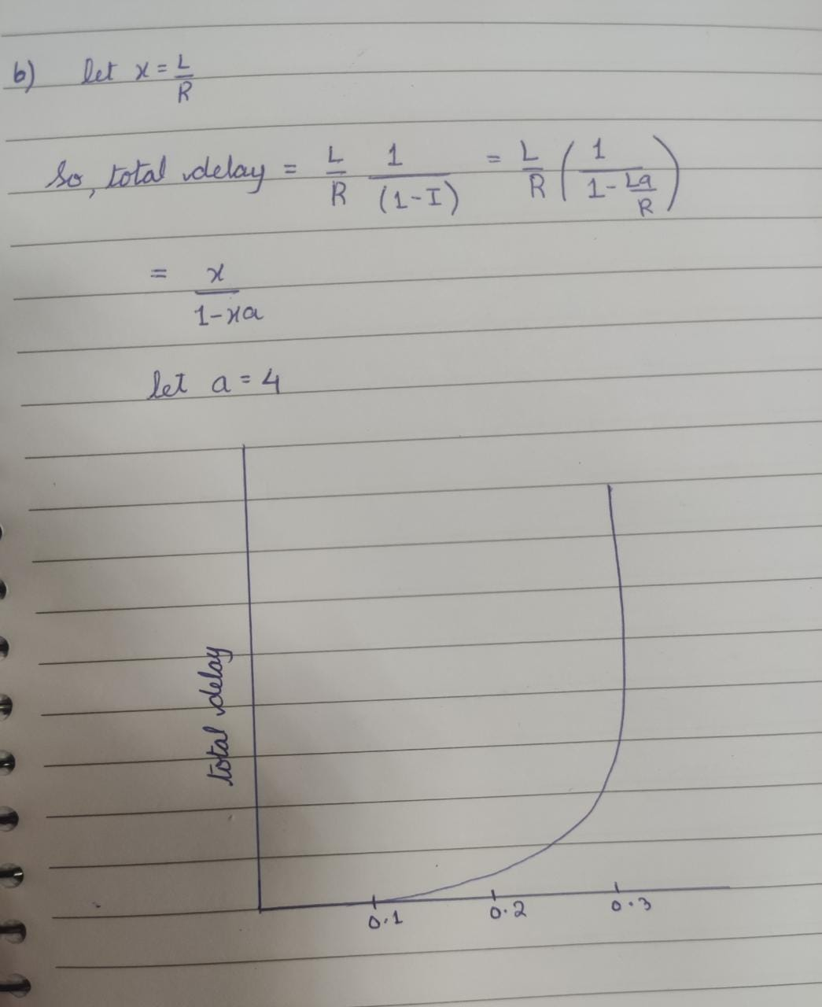

**QUESTION 7:**

Solution:

Distance between two hosts A and B = 20,000 km = 2 x 107 m

Transmission Rate = 5 x 106 bps

Propagation speed = 2.5 x 108 m/s

Propagation delay = dprop = d / s = 2 x 107 / 2.5 x 108 = 0.08 sec

Bandwidth delay product = R x dprop = 5 x 106 x 0.08 = 400000 bits

Solution:

File size = 800,000 bits

Transmission Rate = 5 x 106 bps

Propagation delay = dprop = d / s = 2 x 107 / 2.5 x 108 = 0.08 sec

Maximum number of bits = Bandwidth delay product = R x dprop = 5 x 106 x 0.08 = 400000 bits

Solution:

The product of band-width delay and transmission rate is equal to the maximum number of bits on the transmission line.

Solution:

Transmission Rate = 5 x 106 bps

Propagation speed = 2.5 x 108 m/s

Length of 1 bit on the transmission line = s / R = 2.5 x 108 / 5 x 106 = 50 m / bit

Football field = 91.4 m

Hence, Length of 1 bit on the transmission line (50 m / bit) is not longer than football field.

Solution:

A general expression for the width = R x s / m

**QUESTION 8:**

Solution:

When the user makes call over the skype, the call passes through the internet and reaches both the interface. Then, the call passes through the telecom network and reaches to the desired telephone number. VoIP stands for Voice over Internet Protocol is used in Skype for the communication. It is an internet telephony network based protocol. Hence, skype use this protocol and the interface between the internet and telephone network to make a voice call from a PC**.**